Git & GitHub
-Checking git version by command, git --version
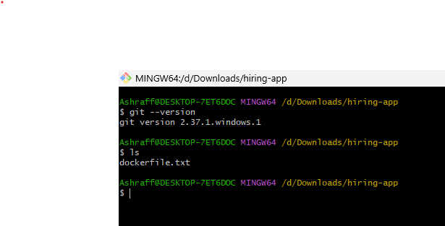
-Initialising git, viewing .git file structure and git status command. git init & git status

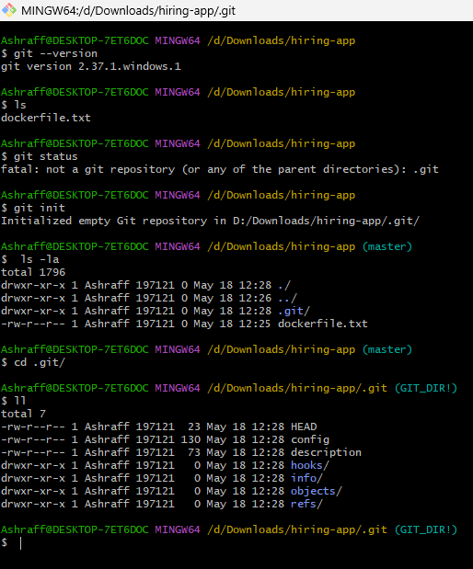

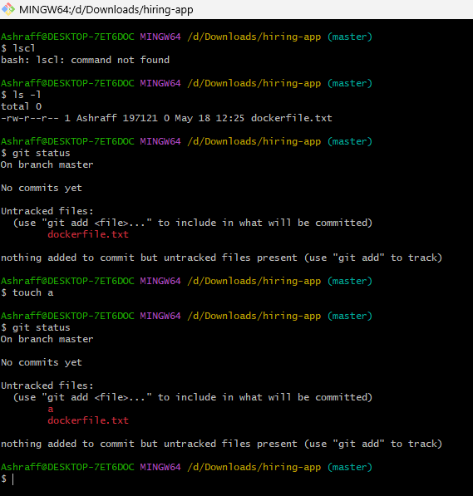

Configure username and user email
git config –global user.name “Ashraff_Shaik”
git config –global user.email ashrafff452@gmail.com
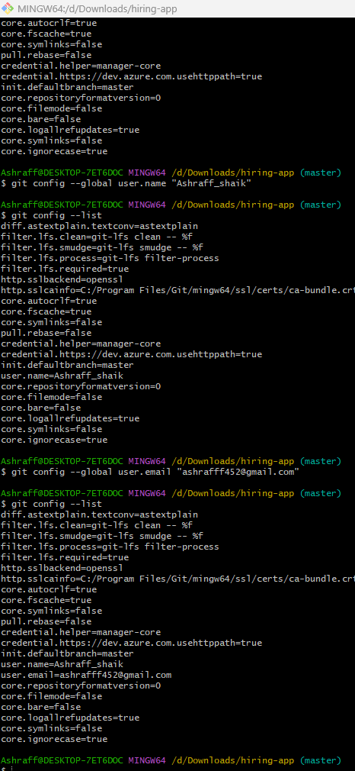
Moved the files from untracking to tracking by the command “git add filename”.
Adding multiple files at a time to tracking area we use the command, “git add . “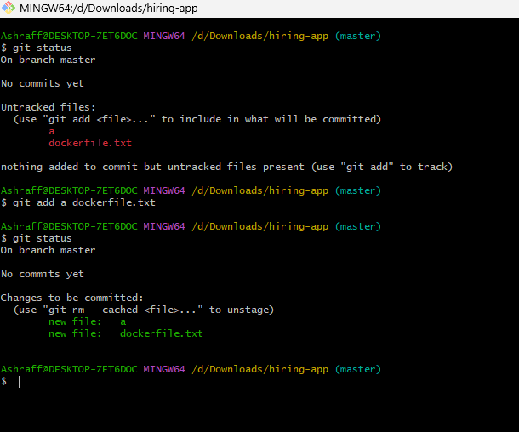

Command, git commit -m “message” is used to commit the changes

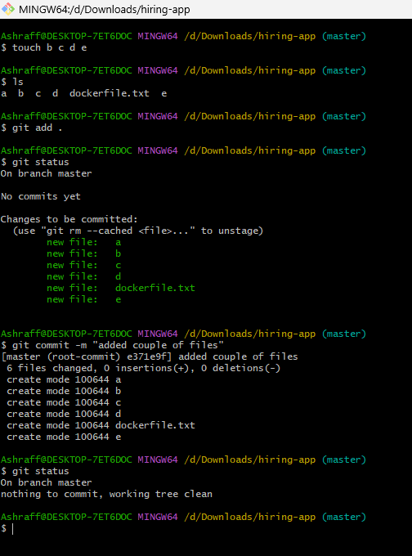

We use “git log” to display all the logs/commits

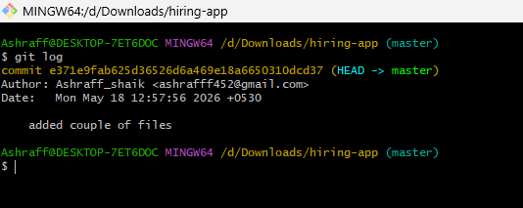

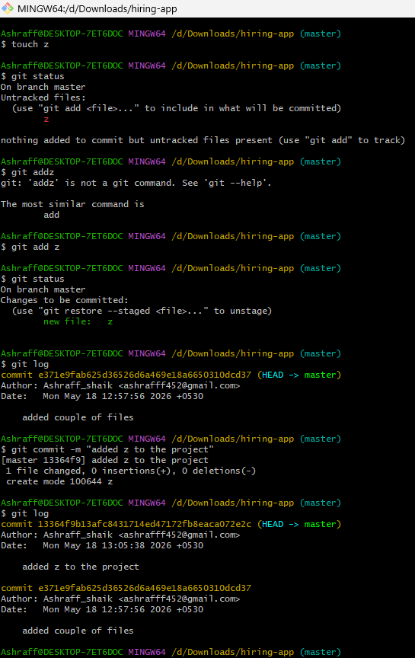
We use command, git remote add origin git@github.com:ashrafff452/GitHub_test.git
To see already configured we use, git remote -v

Later we need to create a GitHub account to push our source code to the central repository

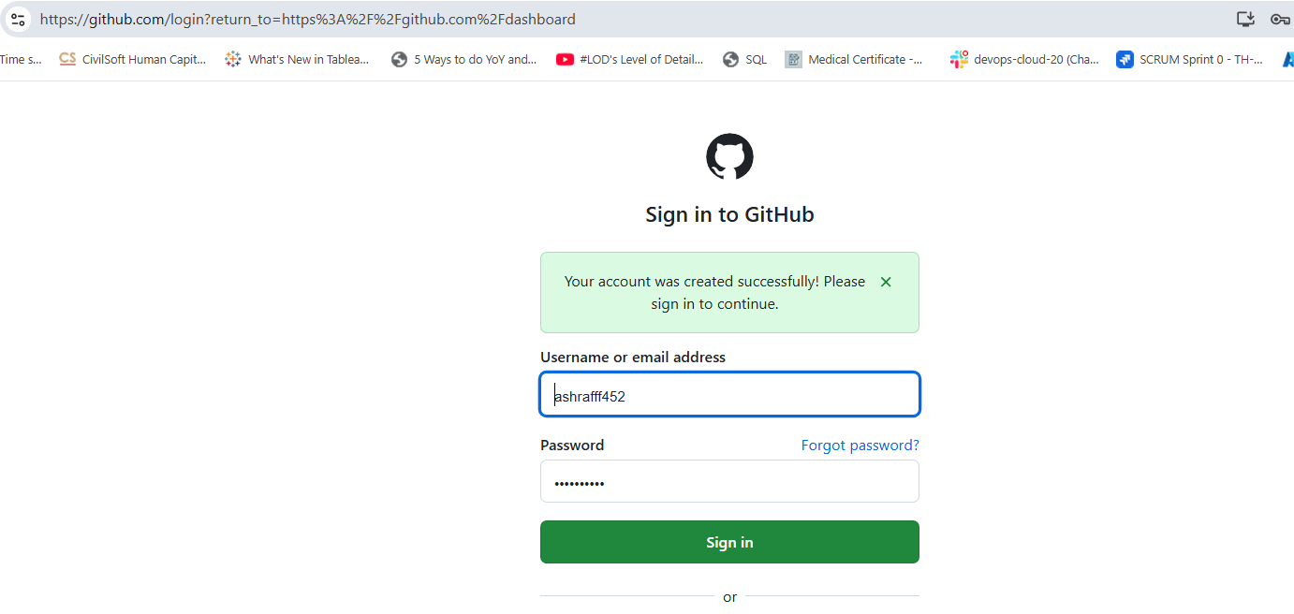

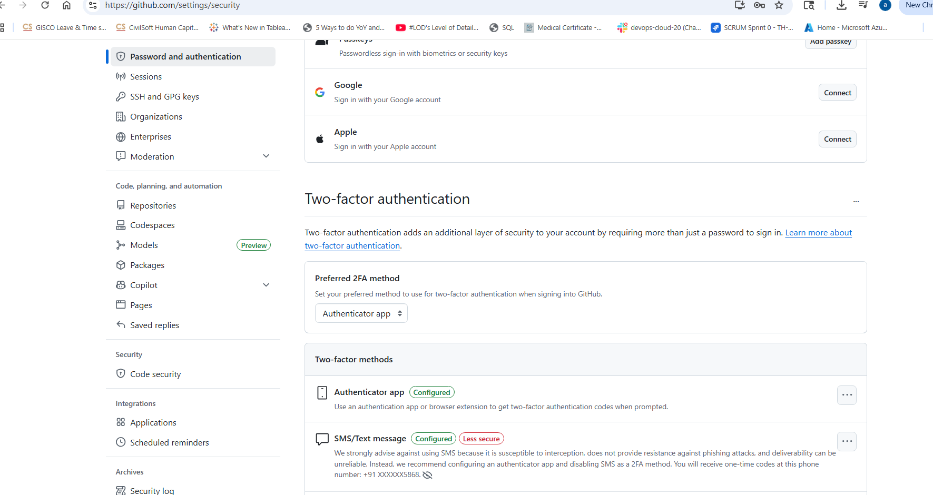

We generate a rsa key using ssh-keygen command in local machine
Copy the path where the rsa.pub key is generated
On terminal mention “cat pathname/rsa.pub”
Copy the ssh key and navigate to github settings menu
Enter SSH and GPG keys section
Click on New SSH key
Name the title as my_laptop and paste the copied rsa.pub key

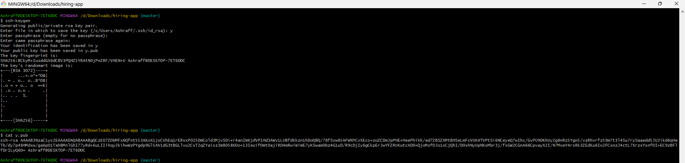
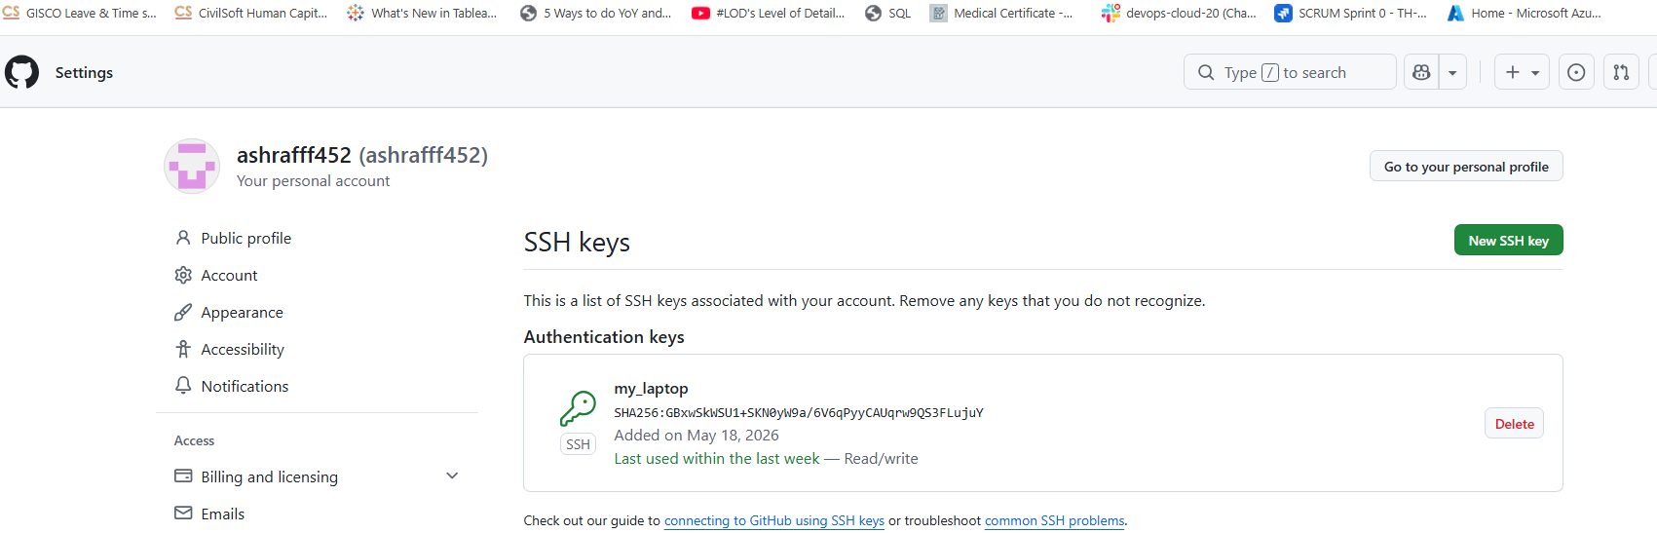

We use git push -u origin command to push the source code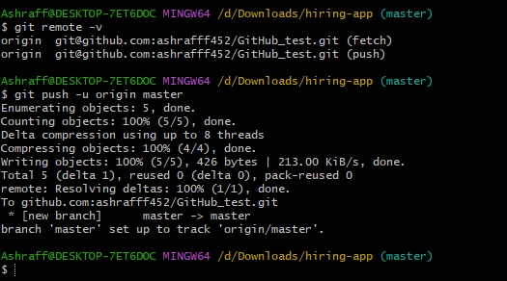
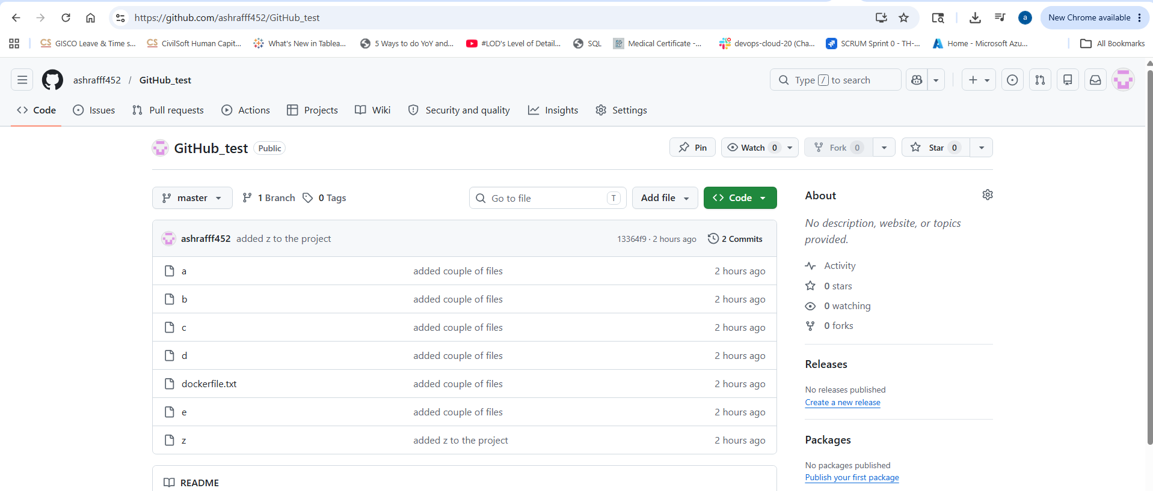

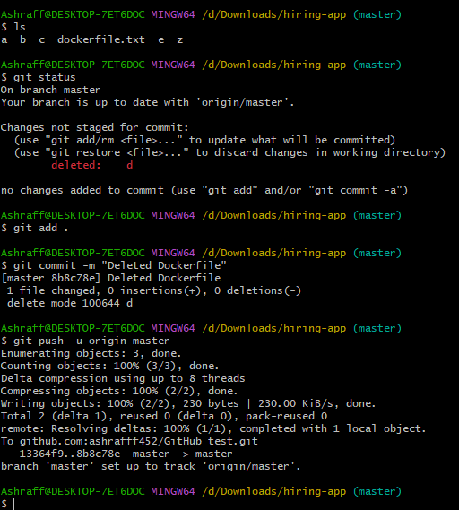

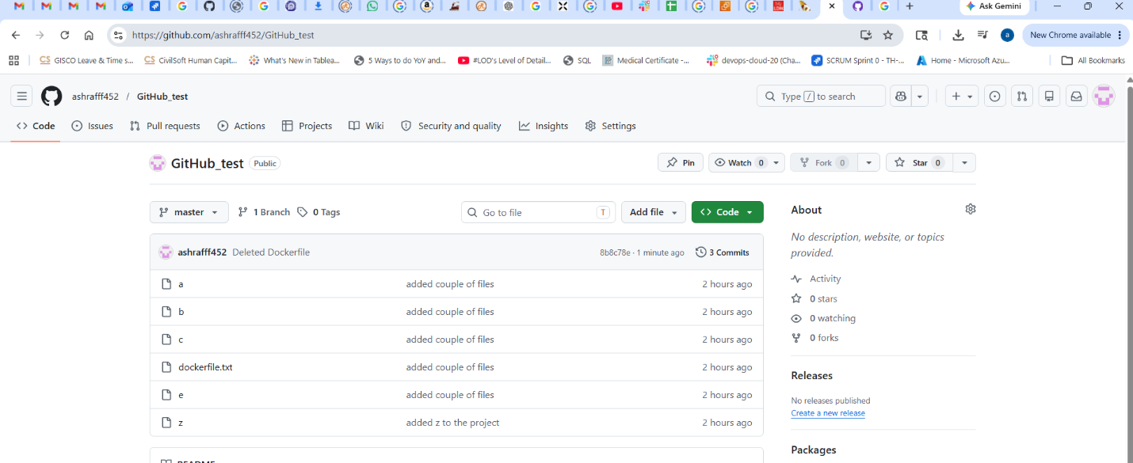
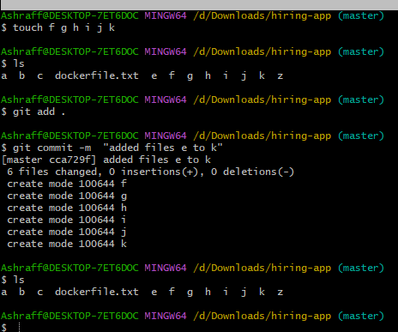

Enter command “git push -u origin master”
Origin is remote destination
Master is branch name.

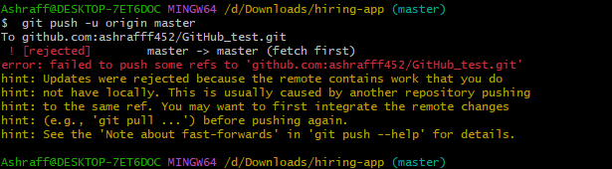

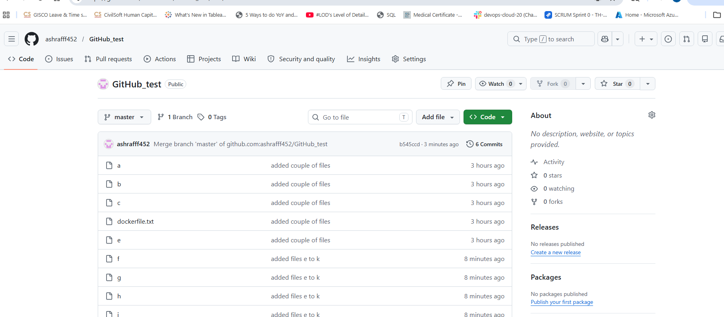

-We use command, git clone git@github.com:ashrafff452/GitHub_test.git to pull the project to local machine

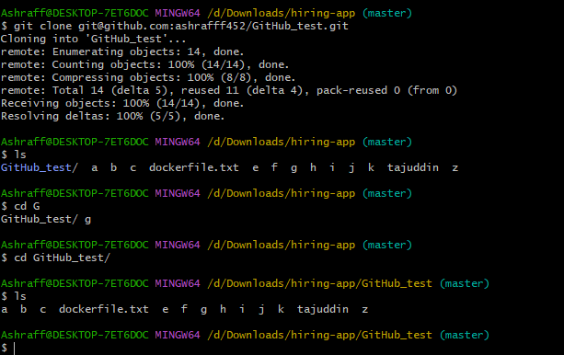

-We use command, git revert <commit_id> to get the deleted file with git log command
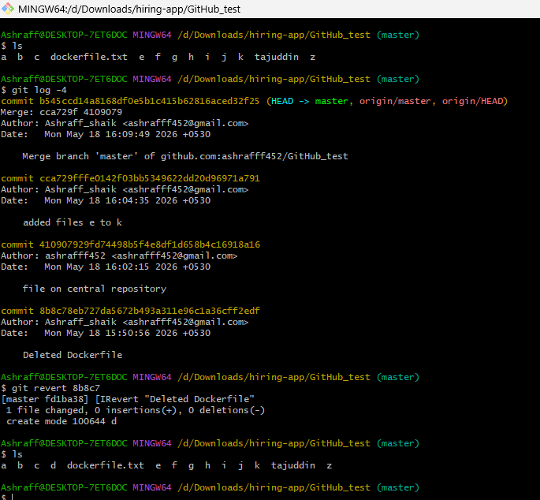

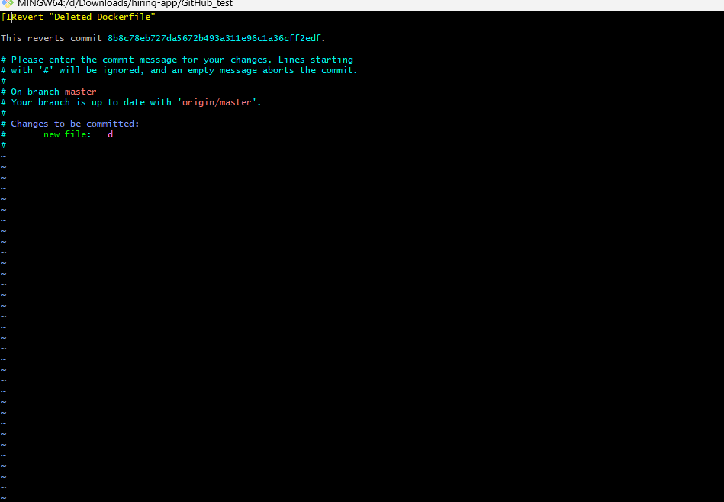
-We use the command git reset to move a file from track to untrack area Which are not committed.
But we can’t do this to already committed files.

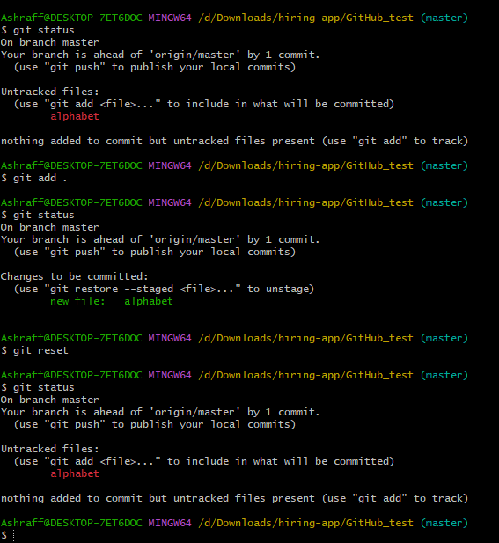

We use git clone command to push the project by deleting the directory in local machine.
We can’t use git pull command to fetch the project instead it is used to fetch a particular missing file

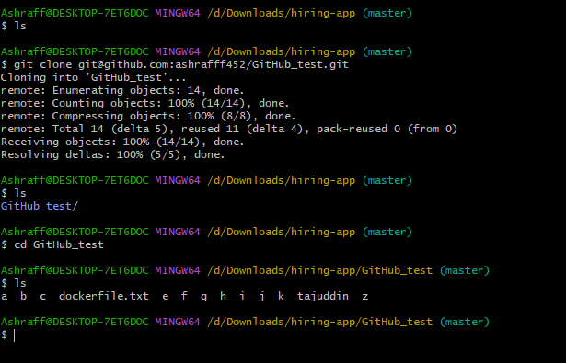
Fork usage:
Using fork option, we can directly copy others repository to our repository and
also can do the necessary changes if required
Or using git clone command with the repository url we can directly download
it to our local machine

